

Mā te āwhina, e ora te torohū o te Kaiāwhina

Nurturing the limitless potential of the Kaiāwhina workforce

Whakapapa o te Kaiāwhina
In 2015 the Ministry of Health (Health Workforce) and Careerforce collaborated on a 20-year vision to develop the Kaiāwhina workforce.
The Kaiāwhina Workforce Taskforce participated in the co-design of the 2020-2025 Plan and will continue to provide governance stewardship for the implementation of the five priority areas of that Plan.
In 2021/22 there were some significant reforms to both education and health. The Reform of Vocational Education (ROvE) saw the establishment of Workforce Development Councils in October 2021, Careerforce as the Industry Training Organisations gifted the Kaiāwhina action plan and taskforce to Toitū te Waiora, (Health, Education and Social Services Workforce Development Council).
In July 2022, the two new national health entities were established - , Te Whatu Ora and Te Aka Whai Ora . The new entities remain committed to supporting the role of the Kaiāwhina and Kaimanaaki.
The Kaiāwhina Workforce Action Plan 2020-2025 is available on the dedicated website kaiawhina.org.nz
The 2020-2025 Plan Priorities are:
- Building cultural capability
- Connecting Kaiāwhina
- Accelerating new ways of working and eco-system thinking
- Creating workforce knowledge and data
- Supplying and developing the workforce

The Advisory Group is managed by Toitu Te Wairoa and is connected to the mahi ofTe Whatu Ora and Te Aka Whai Ora through the Kaiāwhina Workforce Working Group. The Advisory Group will be co-chaired theCEO of Toitū te Waiora and theDirector Workforce, Te Whatu Ora.

Kaiāwhina Workforce Working Group Operational Structure
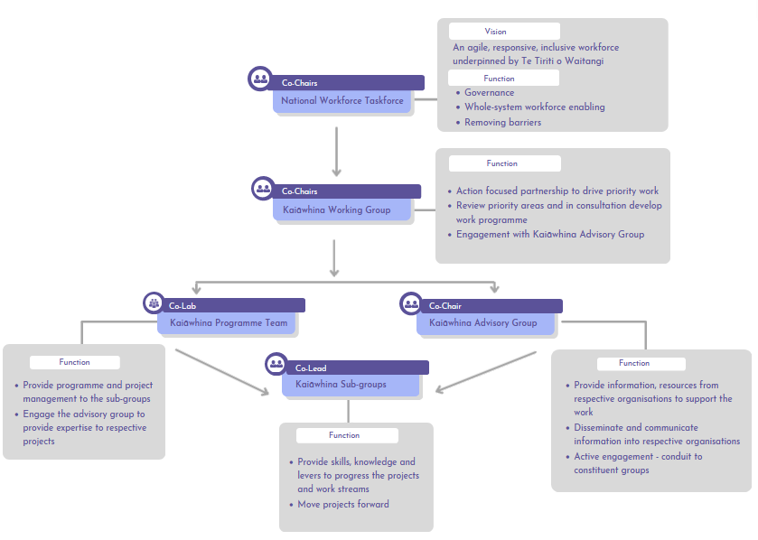

Taskforce Terms of Reference
Kaiāwhina Plan
To acknowledge the mana of an empowered, skilled and valued Kaiāwhina workforce that is an integral part of Aotearoa’s health, disability and social service provision workforce.
The Purpose of the Advisory Group
A partnership between employers, Kaiāwhina, consumers and providers to action and deliver on the agreed priorities to develop and grow the Kaiāwhina workforce. The members of the advisory group will actively contribute to a cohesive and system wide approach to Kaiāwhina workforce development to ensure that the role of the Kaiāwhina is nurtured, highly skilled with clear development pathways to enable better health outcomes for Aotearoa.
Members role to:
- Abide by the principles of Te Tiriti o Waitangi, manaakitanga, kaitiakitanga, and rangatiratanga.
- uphold the objectives of Pae Ora, Ola Manuia and Te Pae Tata.
- Actively promote the role of Kaiāwhina, the work plan, its priorities, and the advisory group.
- To share knowledge and expertise to support achievement of priorities.
- Communicate from and disseminate to respective organisations and relevant networks.
- Active engagement in the mahi of the Kaiawhina Workforce Working Group and project sub-groups.
- Take collective responsibility to achieve plan outcomes.
- Work in partnership with employers to meet employer needs in delivery of contractual requirements.
- Support development of achieving clear pathways for Kaiāwhina roles across the health and wellbeing sector.
Meetings
The Advisory group meets a minimum of four times per annum – dependent on the work programme. Meetings will be held virtually and will be recorded. They will be conducted in a style that is respectful and encourages active engagement from participants. The agenda will be structured with a focus on the sub-groups providing feedback on their current work plans.
Record
The virtual meetings will be recorded. Formal minutes will not be taken but decision points and recommendations will be documented.
Reporting
The Kaiāwhina Working Group will submit a report on progress on the work plan to each Advisory Group meeting. The Report will also highlight any concerns or constraints to achieving progress.
Confidentiality
All work, whether verbal or written, is considered to be not confidential, unless deemed so by the Advisory Chair or on request by a member.
Administration
Toitū te Waiora will provide secretariat support to the Advisory Group.
Review
Terms of Reference will be reviewed annually.

