Kaiāwhina Workforce Development – Future Model
To | Co-chairs National Workforce Taskforce  Kaiāwhina Taskforce
From | Ngaira Harker and Allison Plumridge (Co-chairs, Kaiāwhina Workforce Working Group)
Related documents | Nil
Date | 26 January 2023
Action | Establish agreed relationships and scope for working groups

KŌRERO TĪMATANGA ǀ Introduction
Aotearoa/New Zealand requires a Kaiāwhina workforce that encompasses Te Tiriti o Waitangi and the community values that reflect our diverse population. There is considerable commitment to realising the potential of these roles. The reforms in the health and education sectors provide an opportunity to review the structures around Kaiāwhina workforce development. This provides an opportunity to implement a new model of working to accelerate the delivery of workforce initiatives intended to develop and grow the Kaiāwhina workforce.
Relevant to this paper are:
- The Careerforce and Ministry of Health Kaiāwhina Plan 2020 – 2025 and associated Kaiāwhina Taskforce, which are now under the management of Toitū Te Waiora.
- Te Pae Tata Interim New Zealand Health Plan (2022), Ola Manuia, Te Whatu Ora and Te Aka Whai Ora workforce priorities, the National Workforce Taskforce, and the Kaiāwhina Workforce Working Group.
There is an opportunity for these areas to align and combine. The purpose of this paper is to propose a future structure and function to ensure that they are complimentary and not duplicated. The synergies are apparent and given an agreed structure, they have the potential to be effective in building on existing achievements. This paper explores the approach to build on existing established roles and relationships and the whakapapa of the mahi, underpinned by the principles of Te Tiriti o Waitangi, to support our Kaiāwhina workforce.

TĀ TATOU MOEMOEA ǀ Our Vision
Te Whatu Ora and Te Aka Whai Ora are committed to building a collective and cohesive healthcare system that reinforces Te Tiriti o Waitangi principles and obligations. The 2022 Te Pai Tata interim health plan has identified five main health system shifts, of which priority five makes a commitment to support, value and train health and care workers to meet population need.

Te Whatu Ora has established a Workforce Taskforce, in partnership with Te Aka Whai Ora, to provide recommendations on future workforce development and to identify what is required to deliver transformational workforce change. The approach is grounded in te Tiriti o Waitangi, ensuring Māori are represented in all aspects of the Taskforce’s work. It has a whole-of-system view and will, through its broad range of activity, engage with key sector groups.
The Taskforce has established six workforce working groups – nursing, medical, kaiāwhina, midwifery, allied health and administration and management.
The Kaiāwhina Workforce Working Group is in the establishment phase. The intention is to build on progress made by the Toitū Te Waiora Kaiāwhina Taskforce, and to strengthen national commitment to delivering on this priority.
Our vision for this mahi encompasses effective and respectful relationships within all groups and a shared sense of kotahitanga, oneness.

WHAKATEREHIA TE WHAKA ǀ Setting the Direction
The national work programme must promote Pae Ora and align to Te Pae Tata and Ola Manuia. It is important we acknowledge the whakapapa of the mahi, which has provided a strong foundation for further development. As identified in the introduction, we have two streams of activity to combine, and groups to establish to progress this mahi. Additionally, we need to reflect the changing shape of the health system and ensure that we incorporate further requirements within this Kaiāwhina development.
The structures going forward must:
- Grow, develop, value the mana, and retain a representative and equitable workforce
- Build and develop capability within whānau and communities
- Enable Whānau to achieve Pae Ora
- Enable Pacific communities through the priorities in Ola Manuia
- Build and develop Tangata Whaikaha | Disabled people pathways with Kaiāwhina workforce

Current Group Structure
The National Workforce Taskforce (Te Whatu Ora and Te Aka Whai Ora) the mandate is to develop the health workforce to meet population needs.
Kaiāwhina Working Group - provides an action focused partnership to drive priority work. It is accountable to the National Workforce Taskforce (Te Aka Whai Ora and Te Whatu Ora), to deliver the vision. Once established, the Group will have key representatives from the sector.
Kaiāwhina Programme Team - programme and project management to support the work of the Workforce Working Group to deliver on agreed work streams and priority areas.
Kaiāwhina Taskforce (Toitu Te Waiora) is a key representative group of stakeholders with extensive knowledge and experience. It is essential that these key stakeholders remain actively involved and engaged to represent and provide a voice for and to their respective groups.

Mandate
It is important to ensure that there is a clear mandate for the commission on, and delivery of, the work programme.
Te Aka Whai Ora and Te Whatu Ora are responsible for the commissioning of workforce development and funding of specific initiatives. Note that not all initiatives will require funding.
The role of Toitū Te Waiora Community, Health, Education and Social Services Workforce Development Council is to ensure the vocational education system meets industry needs and gives a stronger voice to Māori business and iwi development.

Proposed future structure for consideration and discussion
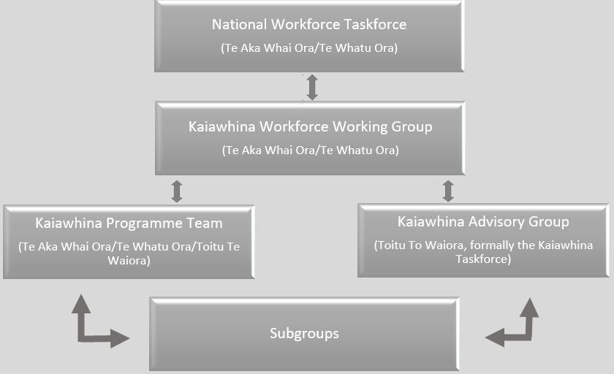

In the above proposed model, the current Kaiāwhina Taskforce transitions to an advisory group, providing information, resources and expertise from their respective roles and organisations to enable the work, and progress the development of the workforce. The Kaiāwhina Programme Team reports to the Kaiāwhina Workforce Working Group. They provide programme and project management to the subgroups, and engage the advisory group to provide expertise and support for the respective projects. Governance of the Kaiāwhina Programme sits with the National Workforce Taskforce.

Next steps
The Kaiāwhina Working Group will be established and undertake a review of the priority areas for Kaiāwhina and develop a proposed work programme. This will then be discussed with the Kaiāwhina Advisory Group and the work-streams and sub groups will be established.

“He Tangata, He Tangata, He Tangata!”
What is the most important thing in the world? It is the people!

The Plan - Developing the Health and Disability Kaiāwhina Workforce (kaiawhinaplan.org.nz)
Te Pae Tata Interim New Zealand Health Plan 2022 – Te Whatu Ora - Health New Zealand

