2023 National External Moderation Plan

MARCH 2023 UPDATED RELEASE

Tēnā koutou katoa

In early February our Manager - Quality Assurance, Wiremu Bayliss, left Toitu te Waiora to join his family in the US.

This role has been seconded to Dr James Dearnley. For those that haven’t met James before, he also manages our Qualifications team and has a wealth of knowledge from working at Careerforce & prior to that NZQA.

We are working on the alignment of qualification and unit standard maintenance, with a sector based focus. From 2023, unit standards will be replaced by skill standards as they come up for maintenace. As part of this project we are integrating the inisghts gathered from unit standard post-moderation to help inform development of related new skill standards.

We will now be prioritising post-moderation of TEO assessment samples within the following domains:

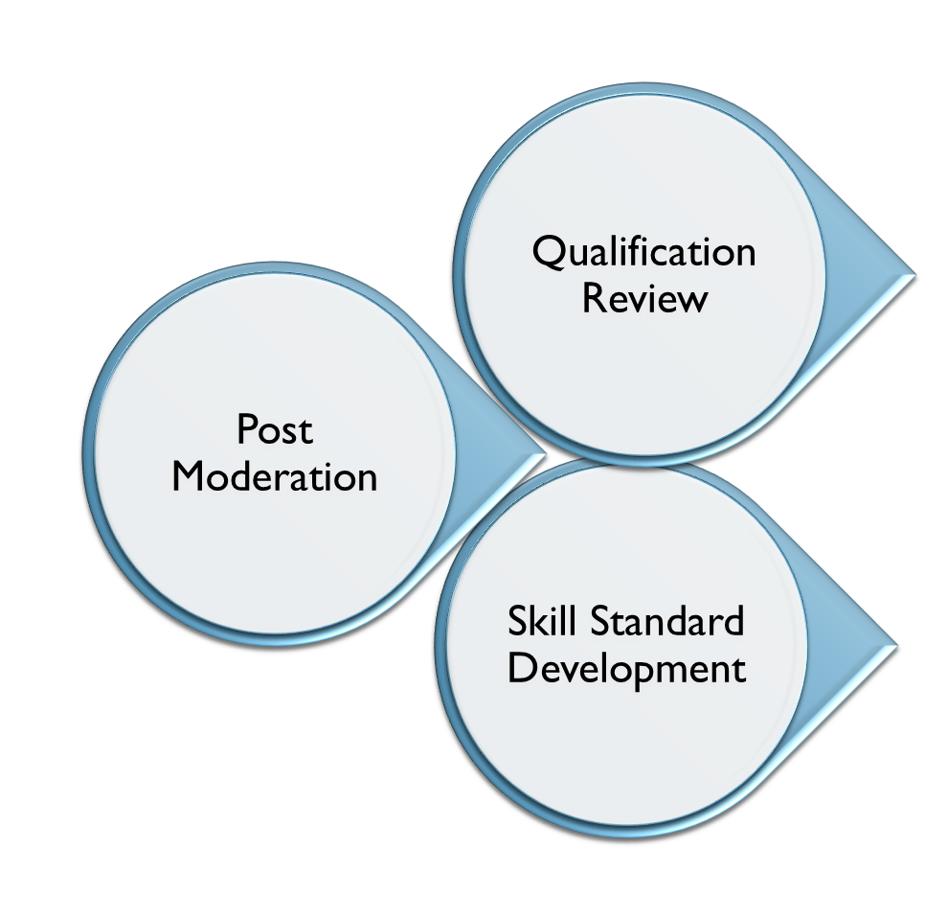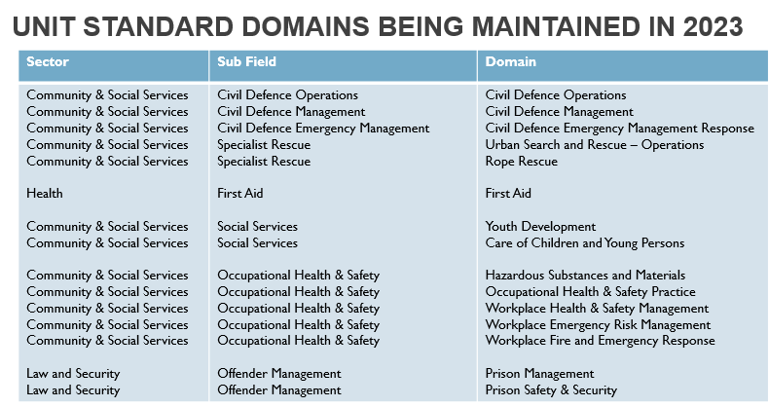

Please feel free to contact usWe look forward to working with you in 2023 and beyond to improve the outcomes of learners in the areas we serve.

Ngā mihi nui ki a koutou.

Heather Kingsley-Thomas
General Manager – Qualifications & Assurance
 | heather.kingsley-thomas@toitutewaiora.nz  022 028 4498  49 Tory St, Te Aro, Wellington  Level 4, 277 Broadway, Newmarket, Auckland  PO Box 445, Wellington, New Zealand  www.toitūtewaiora.nz

Aromatawai – Assessment Practices
Poipoia te kakano, kia puāwai
Nurture the seed and it will blossom

Toitū Te Waiora endorses the NZQA Aromatawai and the principles of assessment 2022. We believe these five principles are the basis for sound assessment design and sound assessment practice. In summary, these five principles are:

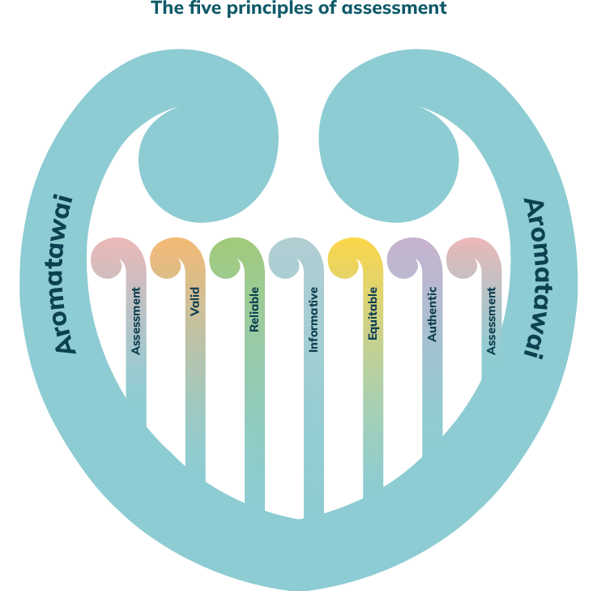
- Pono – assessment is valid
Assessment measures the achievement of learning outcomes, is evidence based, and appropriate.
- Haepapa – assessment decisions are reliable
They are comparable and consistent when made against the same outcomes in different contexts.
- Mārama – assessment is informative.
It is valued, meaningful and purposeful to the context of ākonga achievement
- Tika – assessment is equitable.
It is fair, accessible and values cultural diversity and individual needs.
- Tūturu – assessment show understanding of authentic skills
It affirms skills, knowledge and competencies acquired by ākonga and reflects real world contexts.

We have been applying these principles to our moderation activities. We take a holistic approach, looking beyond whether assessments simply meet the standard expectations against which it is written. We are committed to supporting fair assessment practices for all ākonga, especially for priority communities - Māori, Pasifika and Tangata Whaikaha ākonga.

Post-Moderation Selection
Tē tōia, tē haumatia
Nothing can be achieved without a plan, workforce and way of doing things

We moderate the ‘Assessing Organisation’ (rather than the ‘Reporting Organisation’). If you have contracted another NZQA registered Tertiary Education Organisation (TEO) to assess, we will need to moderate them. It is important to note we moderate TEOs based on the NZQA Quarterly reports, so if your organisation appears as the assessing organisation on these reports you will be receiving the post-moderation sample request.
As mentioned above, we are prioritising unit standards that align to our qualification and standard maintenance schedule. We will let you know the standard samples and sample size being requested.
NZQA is working with WDCs to develop reporting of moderation activities and outcomes. For post-moderation, this reporting will include who we have requested to samples from, the outcome of our post-moderation and any TEOs who have not submitted samples.

We email requests for samples quarterly, asking selected TEOs to submit their internal post- moderation samples for selected unit standards. This will generate from our online portal in Q2/Q3
We ask that you submit your samples within four weeks of our request – please let us know if you anticipate a delay in sending through samples. You will be asked to send:
- copies of the assessment;
- assessor/marking guide,
- your internal moderation results
- any SSB pre-moderation reports
If you assess online, please contact us at moderation@toitutewaiora.nz to organise a digital moderation process.

Post-Moderation Schedule
Haere taka mua, taka muri; kaua e whai
Be a leader not a follower

The following is our UPDATED 2023 Post-Moderation Schedule. We will be calling for moderation by subject areas and seeking provider submissions within that scope from results reported in the previous year.

Provider Submission Schedule
Priority Domains | Occupational Health & Safety  Offender Management  Civil Defence  Specialty Rescue
Field | Community and Social Services |  | Early Childhood |  | Service Sector  Law and Security | Health
Period | February – April |  | May – July |  | August – October | November – February
Domain | - Community support services  - Health and Disability principles in practice  - Core Health  - Whanau ora and community support |  | - EC: Educational theory and practice  - EC: Family, Whanau, Community and society  - EC: Professional practice  - Inclusive education practice |  | - Beauty Therapy  - Salon skills  - Cadet forces generic  - Cadet forces specific | - Workplace Health and Safety Management  - Occupational Health and Safety Practice
Samples from these Domains may be called for throughout the year.
Core Generic – 1827
Occupational Health and Safety Practice – 497
 |  | First Aid |  | Other high risk standards
Standards in this list have been designated as high risk and providers will be called on for moderation independent of the previous lists |  | 6400, 6401, 6402  (conducted with nominated providers in onsite visits each quarter as detailed below). |  | Occupational Safety & Health Practice  17459, 18426, 25044, 25045, 25510  Hazardous Subtances & Materials  29765, 29766, 29767, 29768, 30596  Nominated providers will be contacted and advised if a site visit is required or if this will be conducted through standard moderation.

It is likely through this that some providers may be requested for moderation multiple times over the course of a cycle, however we will endeavour to minimise this where possible.

External Evaluation & Review (EER)
If your organisation is scheduled for an EER in 2023 and want more recent examples for moderation then please make a request to moderation@Toitūtewaiora.nz including the coversheet previously indicated. Please allow sufficient time for completion prior to your scheduled EER. We will not be able to respond to last minute requests.

Factors that determine Focus Areas
Toitū Te Waiora will take into account a number of factors when determining our focus areas for providers and standards for 2023.

While not an exhaustive list, the table below describes the moderation conditions.
 | Provider | Standards
Factors in scope for 2023 | - Historical provider information (on action/improvement plans)  - EER (for non-school providers)  - Industry feedback and focus on provider  - Providers with a new consent to assess.  - High volume of standards assessed by a provider | - Unit standard maintenance schedule  - Health and safety risk presented by the standard  - Legislative requirements and risk presented by the standard  - Industry feedback and focus on standard or sector  - New standards  - High and low usage of the standard

Important Notes
Whaowhia te kete mātauranga
Fill the basket of knowledge

Internal Moderation
Toitū Te Waiora considers internal quality assurance incredibly important, demonstrating a continual cycle of improvement when it comes to assessment practice. Both internal pre and post assessment moderation practices contribute to this, and ensures you are providing the best possible resources to measure achievement for your ākonga.

Consent & Moderation Requirements (CMR)
A working group across WDCs is reviewing CMR documents in an effort to simplify these. We do not currently take applications for consent to assess for domain coverage, but we would welcome your feedback on this as we review the CMR model across WDCs.

A number of Toitū te Waiora CMRs are due for review and were last reviewed before the changes to the Education & Training Act (2020), which acknowledges Te Tiriti o Waitangi obligations. The Tertiary Education Strategy includes priority ākonga, so while we review work on our CMR review project, TEOs with consent to assess, or applying for new consents need to demonstrate their capability and readiness to cater to the needs of Māori, Pacific or Tangata Whaikaha (disability needs) learners.

As part of our CMR review, consideration in regard to review of larger integrated package timeframes will be looked at. Single or smaller integrated package assessments (for example up to five integrated standards) have a review KPI of 20-working days. However, larger integrated packages need more time for evaluation, and a case-by-case target-date will be advised to TEOs submitting these.

Unit Standard Versions
A number of standards have multiple active versions in use. Any standards that require revising outside their scheduled maintenance period will now include an expiry date for any earlier version. This date will align to the next scheduled maintenance period, so it shouldn’t have any negative impact for providers.

The NZQA standard framework (https://www.nzqa.govt.nz/framework/search/index.do) provides detail on the latest version available for unit standards. If you have any questions about programme impact that you contact qualifications@toitutewaiora.nz.

Skills Standards
Skills Standard development has begun, and we are working on the Health & Safety standards to replace the 3 domains highlighted in our introduction. This is a big project and we anticipate these will take most of the year to develop.

We undertand TEOs need time to design new assessments and where a standard is part of an existing qualification the last day of assessment (LDA) needs to allow enough time for ākonga to be assessed. We will ensure that a sufficient period of time is allowed to transition from Unit Standards to the replacement Skill Standards.

Over time, all qualifications will have skill standards that TEOs will need to base their assessments on (including those who use graduate outcomes). When this happens pre-moderation of assessments will need to come though our quality assurance processes.

WDC Online Portal is Coming
Testing is underway for our online portal for TEOs to upload their assessment samples directly into the post-moderation projects. We will keep you updated of progress, and expect this will be opened up for release in Q2.

Wānanga Aromatawai – Online Workshops/Webinars
We are in the planning stage to deliver a series of workshops covering topics of quality assurance, assessment practice, programme endorsement and micro-credentials. We will let you know when and where these will be happening.

Assessments Written by Third Parties
TEOs who use external organisations to write assessments are still responsible for having consent to assess, and need to undertake internal pre-moderation before sending it to Toitū Te Waiora for final pre-moderation endorsement.

Organisations who contract with providers to assess and report their results to NZQA, the responsibility of all the quality assurance processes belongs to the reporting TEO.

We are unable to accept or conduct moderation from TEOs who are not NZQA registered training providers.

Cases of Integration of assessment
Where a request for post-moderation applies to a standard within an integrated suite of assessments and is assessed across multiple modules, we ask that the integrated assessment package be submitted. Where the standards being assessed within the integrated package/s sit across multiple WDC’s we will collaborate with the appropriate WDC/s to undertake the moderation activity.

Disclaimer
Toitū Te Waiora Workforce Development Council as the Standard Setting Body (SSB) reserves the right to call for moderation at any time for any reason and may make amendments to this plan through the course of the year, and these will be communicated through our website as well as through email contact. We encourage you to keep an eye out for updates which will be sent to the moderation contact for your organisation which is listed on our system.
We also reserve the right to call for more samples at any point of the year and these will be communicated appropriately to the organisation directly.

Document Version Updates
- March 2023 – Version 2 – UPDATE
- January 2023 – Version 1 – Release

