Date: | 17 January 2020
To: | Health Workforce Advisory Board  Deputy Director General Health Workforce, MoH  Health Workforce Directorate leadership team, MoH
From: | The Kaiāwhina Workforce Action Plan Programme Team
Subject: | The Kaiāwhina Workforce Action Plan – Review of Return on Investment and Value

Background
The Kaiāwhina Workforce Action Plan (the Plan) launched in July 2015 is owned by the sector and overseen by a partnership between the Ministry of Health (the Ministry) and Careerforce, the Industry Training Organisation (ITO) for the health and disability sector. The Ministry has made a significant commitment in the development, implementation and promotion of the Plan. This document provides a summary overview of the value return to the Ministry and Health Sector on that commitment and any investment, financial or in time and resources.
The Starting Line
In order to be able to measure where we have got to and what the returns are, we need to understand the landscape before we started.
TRoQ
In 2013 stage one of the Targeted Review of Qualifications (TRoQ) for the health, disability and social service sectors enabled a focused analysis of the career pathways and training being offered to Kaiāwhina. Prior to this, training was disparate and local and national qualifications confusing, so no clear and coherent career pathways could be described. This was addressed through the development of the New Zealand Qualification Authority (NZQA) endorsed framework of New Zealand qualifications for these sectors. This work, facilitated by Careerforce the Industry Training Organisation (ITO) for the health and disability sector, saw all of the sectors come together to agree the career pathways and the qualifications within them. This framework also provided a valuable foundation for recognising the Kaiāwhina roles and the competencies they require to meet the needs of the consumers they support. The development of the qualifications and career pathways was underpinned by the agreed vision to build a person centred, thinking workforce.
NZNO Submission
Around the same time as the TRoQ was happening, the New Zealand Nursing Organisation (NZNO) Submission on the 18th Session of the Human Rights Council 2013 indicated that there had been significant growth in the employment of an unregulated workforce’ with ‘no single definition of the unregulated health workforce or any agency responsible for collecting workforce data’. They also emphasised that despite the significance of this workforce no strategy existed to inform its on-going development and there had been no discussion around how unregulated health care workers would contribute to the collaborative team to improve health outcomes’. The submission also noted the over representation of Māori in the unregulated health care workforce and that the lack of data on this workforce provided a barrier to achieving health equity for Māori
Caring Counts
Caring Counts, Tautiaka Tika Report of the Inquiry into the Aged Care Workforce; May 2012; by the Human Rights Commission, strongly recommended investment in training to ensure carers gained the skill sets required now and, in the future, and points to the finding that 61% of the community support workers had no formal qualifications and 46% had no qualifications at all.
This report along with other national documents are collectively acknowledged for providing the impetus for improvements across the Health and Disability sectors and highlighting the need for developing the unregulated workforce.
BERL Report
Data on the Kaiāwhina workforce has been scarce, in part because there has not been a common title that could be used in census data. Contracts do not typically require workforce information and a proportion of this part time and casualised workforce work for more than one employer at the same time. The workforce is employed by private, public and not for profit entities that have varying ability to collect data.
In response to the absence of reliable data, Careerforce commissioned Business and Economic Research Limited (BERL) to profile the Kaiāwhina workforce,using official statistics from the 2013 Census.
Their Report found there were about 63,000 people in the Kaiāwhina workforce. The demographic profile was older, female dominated, with greater ethnic diversity and lower income and qualifications than other parts of the New Zealand workforce.
TAS shared its Health Workforce Information Programme data on non-regulated District Health Board (DHB) employees, which showed a similar demographic profile.
The Burning Platform
So now we knew that the situation was pretty dire. In a health care system that for the Kaiāwhina workforce had:
- No consistent systems and standards
- No co-ordinating framework or supporting infrastructure for Kaiāwhina who are estimated to make up more than 40% of the health and disability workforce
- No national qualification framework
- No whole of system consistent workforce data
- Job insecurity with a high workforce churn and difficulty recruiting
- Increased demand from an ageing population with increasingly complex cares
- Complex funding and commissioning to navigate
- Heightened tensions between stakeholders with competing agendas, and
- That the workforce was providing significant direct care and support to service users, often the most vulnerable New Zealanders, but was also:
- Under-valued, invisible and had ‘no voice’ within the health and disability system
- An ageing largely female workforce earning minimum wage
- Diverse with over representation of Māori, Pacific and Migrant workforces
- In jobs of last resort with no career or qualification pathway or recognition of experience or transferable skills
In addition, there was nowhere to have the conversation; no environment that was safe for employers, unions, funders and commissioners, government, consumers, educators and the workforce to come together in any combination, let alone all together.
Courageous Leadership and the Investment
When we tell this story, we talk about courageous leadership because that is what it was. In 2014, Graeme Bennie, Director of Health Workforce New Zealand (HWNZ), Ministry of Health backed by the HWNZ board together with Ray Lind, CE of Careerforce backed by the Careerforce board took up the challenge to make a change in the lives of all New Zealanders and the critical workforce that supports them.
The Ministry of Health had the authority and Careerforce agreed to make the dollar investment enabling both to “walk the talk” and disrupt the slow scoping of good ideas without implementation that was often the norm at the time.

Our aim collectively is to build a workforce that is sustainable into the future as the demographics change and a workforce that is valued, so that it can increasingly be a part of integrated delivery of caring services.
Richard Westlake, Chairman, Careerforce

Richard Westlake, Chairman, Careerforce

We support this plan, we endorse it and will be doing everything in our power to assist Careerforce and you as stakeholders in this plan, to recognise and develop the skills of our Kaiāwhina.
Dr Graeme Benny, Director, HWNZ

Dr Graeme Benny, Director, HWNZ

The findings from the BERL research were presented at the Careerforce Workforce Conference in May 2014, where the Ministry of Health and Careerforce announced the launch of the Kaiāwhina Workforce Action Plan
Both Careerforce and the Ministry have made a significant investment since the Plan’s development in 2015.
The Ministry of Health funds the three consumer representatives to participate on the Taskforce and staff from the Health Workforce Directorate (the Directorate) participate as a co-sponsor, co-chair, and joint responsible owner. Ministry staff from other directorates also hold roles on the Taskforce and Working Group.
Careerforce makes a significant dollar investment to fund the facilitation, secretariat and marketing functions. In addition, Careerforce staff hold roles on the Taskforce, within the working group, and the programme team.
The sector commitment to take up the mantel of Kaiāwhina workforce development and recognition has required them to also invest in the Plan.
The 30+ Taskforce members (including those from the Ministry and Careerforce) have made themselves available for 3-6 meetings per annum, with their time and travel funded by their own organisation. We also ask the Taskforce to participate in other ways outside the formal meetings process and particularly to seek opportunities to promote the roles and contribution of Kaiāwhina and to seek the support of their networks to advance the Plan actions.
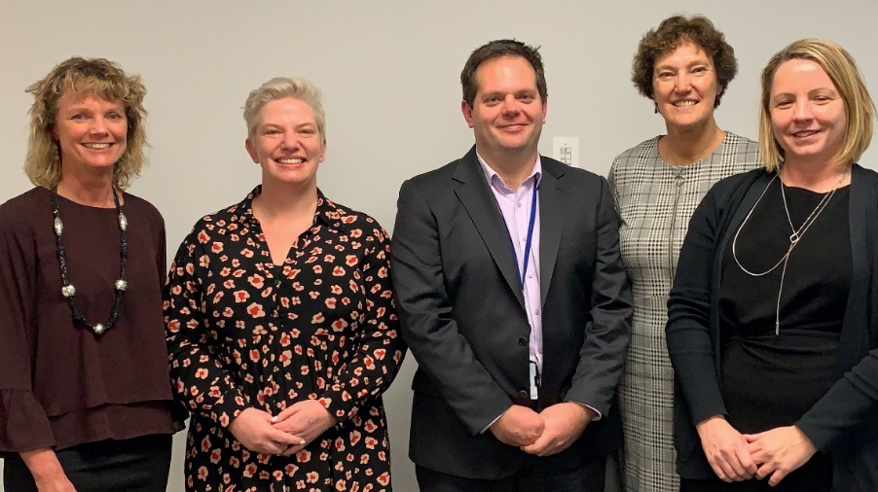
The return on the investment made by the Ministry cannot be underestimated. While the mandate given by the Ministry provided breadth and power, the investment in the co-design of the Plan and its seven domains became the catalyst for action.
From left to right
Gill Genet, GM Business Development, Careerforce; Responsible Owner
Anna Clark, DDG Health Workforce, Ministry of Health; Sponsor and Co-Chair
Daniel Glover, Manager Sector Engagement and Implementation, Health Workforce, Ministry of Health; Responsible Owner
Cathy Cooney, Independent Facilitator, Kaiāwhina Workforce Action Plan
Jane Wenman, CEO Careerforce; Sponsor and Co-Chair

The Value of the Common Agenda
From the time the Plan landed the Kaiāwhina workforce became the common agenda. That agenda is reflected in the 20-Year Vision; “A Kaiāwhina workforce that adds value to the health and wellbeing of New Zealanders by being competent, adaptable and an integral part of service provision” and is laid out clearly in the seven domains, 22 outcomes and 53 actions of the Plan.
The collective response to giving the unregulated workforce a name, Kaiāwhina, was a seminal and singularly powerful step towards supporting that agenda.
The Plan reinforces the Ministry’s position as a leader in the transformation of this workforce and a working partner within the whole of sector.
The doors now opened to have the (sometimes difficult) conversations with industry and workforce, funders and commissioners, educators and the government stakeholders.
The Plan allowed for greater clarity in the commissioning contracts, and joined the dots between competency, pay and qualifications.
But more than that, it positioned career development, training, qualifications and pathways as a critical component of developing and valuing the workforce, and ultimately improving the quality of care for consumers of services and supports.
The Ministry of Health logo sits beside the Careerforce logo on all documentation and communication. In every forum and sector engagement, the Ministry’s committment to the Plan is acknowledged, enhancing the Ministry’s reputation as a collaborative and enabling partner in the sector. The Ministry of Health and the Health Workforce directorate have become role models for driving progress.

Supporting the Ministry of Health Purpose and Values
The Ministry of Health has a unique role as the steward of the health and disability system. The investment and leadership role in the Kaiāwhina Workforce Action Plan has given effect to that role and the Ministry of Health purpose:
The Ministry works across the health sector to deliver better health outcomes for New Zealanders.
The Health Workforce directorate is responsible for creating and supporting a clear strategy and future pathway for health workforce in New Zealand. This includes workforce policy, planning, commissioning of training, and supporting the development and implementation of innovative workforce initiatives across the sector, including with DHBs.

The Plan allows the both the Ministry of Health and the Health Workforce Directorate to demonstrate “living its values” and its purpose in tangible and meaningful ways. This has been an opportunity to lead by example and put words and intentions into action. It has been an outward and inward facing opportunity for expression of the Ministry’s purpose as the steward of wellbeing for Aotearoa. The Directorate and its predecessor HWNZ have been able to hold up the Plan as active implementation of its priorities and its framework for developing New Zealand’s workforce.

The Value of the Independent Facilitator
During the initial discussions in 2014 leading to the formation of the partnership between the Ministry of Health (Health Workforce New Zealand) and Careerforce, the need for an independent facilitator was identified. To ensure that the whole of sector would sit as equals at the table, having an Independent Facilitator was determined to be an important component for both progressing the work with the sector and leading the co-design process on behalf of both parties to the partnership.
The credentials of the facilitator needed to cover a number of attributes including the person’s standing and credibility in the health and disability sector and ability to connect with a wide network of influencers including at strategic and policy levels; having an understanding of workforce development, inter-professional roles, career pathways and progression, and competency frameworks and standards; having knowledge of health and disability systems and structures; their grasp on the work and skill of Kaiāwhina and the potential they have to fulfil new and emerging roles given the appropriate learning and experience; and holding a vision and passion for making a positive difference in the lives of individuals, families and communities were all deemed important to the success of the Plan for the long-term.
Cathy Cooney was contracted to undertake the role. Uniquely qualified, having held positions as a DHB Chief Executive and Director of Nursing (DoN), Cathy also represented the DHBs during the TRoQ process and was the Lead DHB CEO for the Workforce Portfolio over a number of years. Well-connected and highly regarded in the sector, she brought deep and influential relationships together with the leadership and management skills needed to drive the implementation of an ambitious and aspirational Plan. Cathy is a champion of the Kaiāwhina workforce and has been able to leverage her other roles and connections in the sector to promote the work of the Plan and join the dots for sector stakeholders with the work and purpose of Health Workforce and more broadly the Ministry of Health.
The contracting of the Independent Facilitator through the co-design process, and the consistent leadership provided over the period of the Plan, has been a contributing factor to delivering on the result and to giving confidence to the many organisations involved in delivering on the actions. In particular the role has helped maintain the focus on the 20-year vision, the common agenda and in achieving forward momentum on the Plan actions.
The Ministry is viewed differently by the sector when it isn’t leading the conversation. As a result, it has been easier to collaborate and build stronger partnerships with the Plan stakeholders. Independent facilitation has enabled the Ministry to listen and participate as an equal, resulting in a different type of conversation with the sector. The partnership positioned Ministry as a sector leader, but the independent facilitation tempered the dynamic to one of servant leadership open to all perspectives and this positioning continues to open doors for Health Workforce.

The Value of the Taskforce
The overall infrastructure was the driver of the place for the conversation, sector cohesion, the call to action and the collective momentum and accountability.
The Kaiāwhina Workforce Taskforce is inexplicably linked to the Directorate through the shared facilitation of the conversations. The Taskforce brings together 30+ influential members from across whole of sector. It is a forum for the Ministry to hear the independent views of the sectors and consumers.
Most significantly it is a safe place for stakeholders across the sector, employers, unions, funders, commissioners, government, consumers, educators and the workforce; to set aside any tensions and competing agendas. Before the Plan, sector engagement could be difficult to access and at times conversations were constrained and without a common agenda and this did not always drive a forward momentum for the Ministry as well as for the benefit of this workforce.
The Taskforce provides governance of, and guidance to, the Plan and more broadly the Taskforce members both individually and collectively influence and provide guidance to the broader sector. In this way the Plan has become a platform for the collective voice.
The Value of the Working Group
The dozen members that make up the Kaiāwhina Workforce Action Plan Working Group, described as the Plan’s “engine room”, drive the implementation of the outcomes and actions.
Ministry staff currently hold two positions within the Working Group, embedding the Ministry in a unique dynamic with other influential and committed “doers” from the sector that are propelling the work of the Plan forward. The Ministry has access through the Working Group to connect their work to the Plan. This means that the Plan is able to be leveraged to promote the Ministry’s priorities like achieving equity, primary care and quality improvement for example, and to take guidance from the Working Group to ensure work programmes are appropriate, relevant and meeting the needs of the sector.
The individual domain leads of the working group each have supporting formal or informal networks that are mobilised as required on the evolving priorities of the Plan. This extends both the range of “specialist” input into the work of the Plan and also the sphere of influence. That sphere of influence is ultimately available to the Ministry by association.
The refresh of the Plan, midway through its 5-years, to ensure that the actions remained fit for purpose in progressing towards the 20-year vision, was driven by the Working Group and the Programme team with guidance and feedback from the Taskforce. This gave a fresh endorsement to the worth of the Plan and the Kaiāwhina workforce. It reinforced the living nature of the Plan and demonstrated how much “skin in the game” that the Ministry, Careerforce and the other Plan stakeholders had in the outcomes for Kaiāwhina and the people that they support.
Achievement Examples
The development of the Kaiāwhina Workforce Action Plan is in itself a significant achievement. That this Plan has not sat on a shelf collecting dust as many others have, but has been seen as a living plan, which has been refreshed as required to be responsive to the ever-changing environment, consumer need and sector demand, and which has been regularly reported on and had its progress monitored, is a testament to the Ministry’s vision and commitment. This committment has been leveraged at every opportunity to align with and support both the Ministry and Health Workforce priorities and is now so embedded in the Health Workforce directorate business that the two are hard to separate.
With less than a year remaining on the 5-year Action Plan, there has been completion or significant progress of 44 of the 53 actions. We anticipate that all actions will have been significantly progressed by June 2020 which is the end of the current Plan. Promotion of such success and achievement will in its turn provide a further opportunity to promote the Kaiāwhina workforce and the leadership of the Health Workforce directorate.
The progress for some of the actions is directly attributable to the Plan itself, while for other more challenging actions the plan has created a place to join the dots and to jointly problem solve across multiple stakeholders thus giving confidence to the sector that these complex actions will be achieved over the long term. What is clear to everyone involved in the Plan is that forward momentum has been achieved across all seven domains over the first 4 years of the Plan and that the goal of having a place to have a conversation about this workforce and to provide collective leadership has been achieved. This is increasingly acknowledged by sector leaders including Taskforce members and senior leadership of the Ministry.
During the Pay Equity settlement process, the Taskforce provided a safe table to have conversations and for sector representatives to step back and see the larger scope of the Plan
The Naming of the Workforce
Throughout the consultation with the sector and stakeholders, the issue of the term unregulated or non-regulated was repeatedly raised as being disrespectful, demeaning and pejorative.
Kaumātua Wi Keelan (Ngāti Porou/Ngāti Kahungunu/Rongomaiwahine) who held the role of Chief Advisor Māori in the Ministry of Health in 2014, championed the name Kaiāwhina for this workforce in response to this request.
This distinctive role is captured within te reo Māori to reflect the ngako, the deeper meaning of the term:
Kai person performing a role Āwhina to support and assist
Phase one of the five-year Kaiāwhina Workforce Action Plan was jointly presented by the then Director of Health Workforce New Zealand, Dr Graeme Benny, and the Chairman of the Careerforce Board, Richard Westlake, to the Careerforce Workforce Conference held at Te Papa in May 2014. The term Kaiāwhina was endorsed by national and international speakers as a fitting title that embraced New Zealand’s unique identity and the roles and contribution of the non-regulated health and disability workforce.
The naming of the workforce gave immediate equality to Kaiāwhina alongside the other health and disability workforces. The Health Workforce New Zealand Strategic Plan, Statement of Intent 2014-2018 document provided visual representation of this equality.

Health Workforce New Zealand Strategic Plan

Statement of Intent 2014 to 2018

Vision: A health care workforce in New Zealand that is sustainable, flexible and fit for purpose
Underpinned by the Triple Aim Approach

Medical Workforce

Nursing Workforce

Allied Health
Workforce

Leadership and Management

Kaiāwhina Workforce
Midwifery
Workforce

Along with the name there came the credibility and mandate for the Plan. It powerfully connected the work into the Health and Disability system and helped counteract the sector dismissiveness to this often-marginalised workforce. In articulating the mandate in this way, the Ministry has been able to position itself as a true champion of Kaiāwhina and workforce equity, reinforcing the values of the Ministry and its role as a sector leader.
In 2018, during discussions on how the Plan could ensure its commitment and obligation to Te Tiriti o Waitangi, it was realised that telling the story that came with the taonga (treasure) of the name for the workforce - Kaiāwhina, would allow the sector to better understand the inherent mana of the word and of the title Kaiāwhina. In 2019 the word Kaiāwhina is accepted as the umbrella term for the health and disability sector non-regulated workforce and increasingly appears in documents and correspondence.
Driven by the Working Group brief, and in consultation with Wi Keelan, Whakapapa o te Kaiāwhina was developed. This document provided step progress in articulating the mana and value that Kaiāwhina hold in the health and disability sectors. The content is embedded in the plan document and is available in a non-branded poster. This work is a useful device to help the Plan and the sector promote the workforce and for the Ministry to use in development and review of the programmes of work that support Kaiāwhina. More significantly, this is something that Kaiāwhina can use to uphold their own mana as an integral and important part of the Health and Disability workforce.
Policy, Strategy and Research
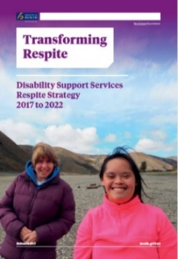
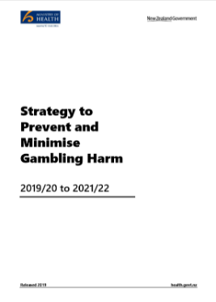
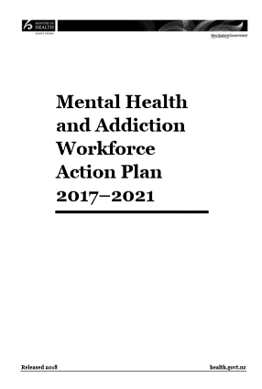
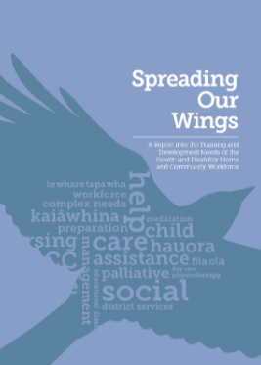
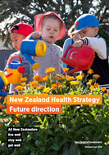
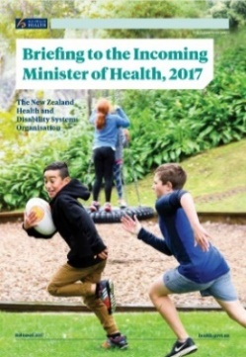
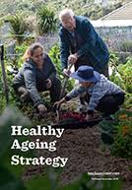
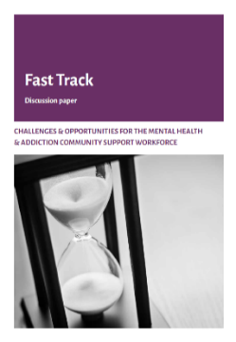
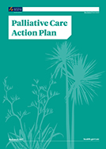
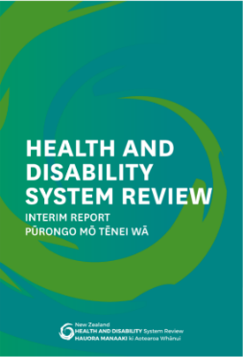
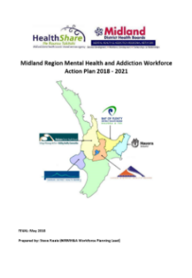
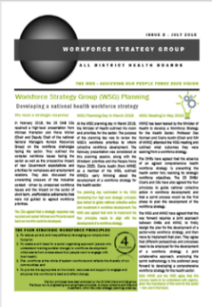
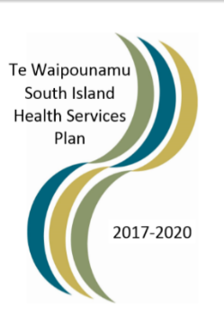
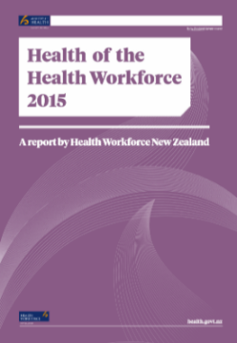
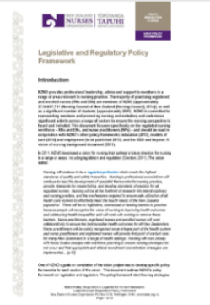
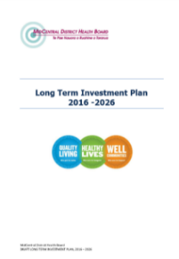
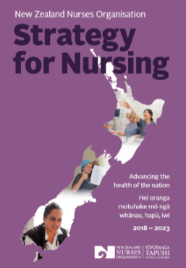
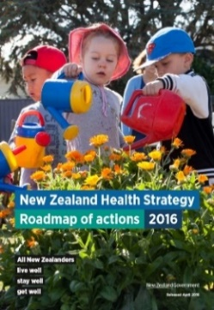
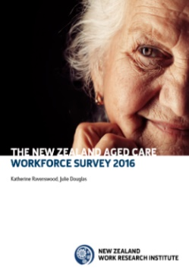
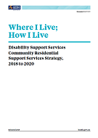
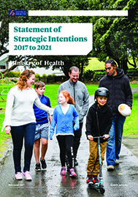
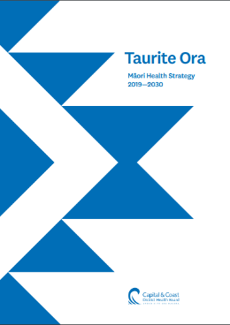
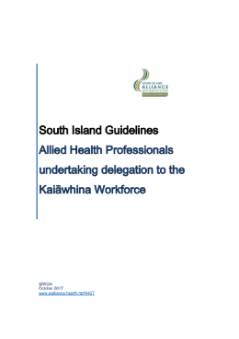
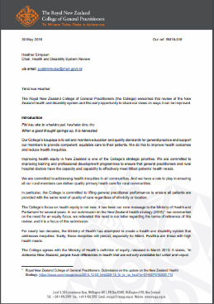
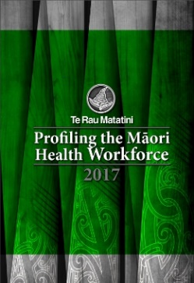
In 2014, the Kaiāwhina workforce was rarely acknowledged in policy, planning or research. Five years later they are now specifically mentioned in all relevant national health and disability strategies, workforce plans, policy and research. The following documents each provide evidence of this uptake and recognition of the Kaiāwhina workforce and in many instances also reference the Plan. Each instance reaffirms the leadership of the Ministry and the Health Workforce Directorate of this work.

Following are examples of quotes from some of the documents identified above:
Strategic Actions: NZNO will work with Health Workforce New Zealand and Careerforce to ensure that RN clinical leadership, direction and delegation is integrated into planning and implementation of the Kaiawhina Workforce Action Plan Framework
- Strategy for Nursing, Advancing the health of the nation 2018-2023; New Zealand Nurses Organisation; 2018

Milestones Dashboard 2017-20
Item 3 - Kaiāwhina workforce: AHAs are fully utilised in the delivery of care. Ongoing feedback to ensures the qualification remains relevant to the health sector
Item 4 - Kaiāwhina workforce: The NZQA Level 4 Health and Wellbeing qualification is included in the AHA development framework
- South Island Health Services Plan (2017-20); South Island Alliance; May 2017

This section of the paper outlines other key issues identified in relation to the development of the community support workforce. The issues and some of the implications have been organised under the broad headings used for The Health and Disability Kaiāwhina Workforce Action Plan Framework).
- Fast Track Discussion Paper, Challenges & Opportunities for The Mental Health & Addiction Community Support Workforce; Te Pou o te Whakaaro Nui and Platform; July 2017

Action 9.c. Progress training packages to enhance the capacity and capability of Kaiāwhina to support people with long-term conditions and their families and whānau, as part of the Kaiāwhina Workforce Action Plan.
Lead Partners: Careerforce, Health Workforce New Zealand
- Healthy Ageing Strategy 2016; Ministry of Health; 2016

A number of other strategies and action plans, including the Healthy Aging Strategy (Associate Minister of Health 2016), The Health and Disability Kaiāwhina Workforce Action Plan (HWNZ and Careerforce 2014)), the Mental Health and Addiction Workforce Action Plan 2017–2021 (Ministry of Health 2017d) and The Disability Workforce Action Plan 2013–2016 (Ministry of Health 2013b), are already seeking to increase the availability of a competent, qualified, adaptable, person-centred workforce. Improving the availability of a skilled respite workforce is linked to actions within these other strategies and action plans.
- Transforming Respite Disability Support Services Respite Strategy 2017 to 2022; Ministry of Health; July 2017

Workforce Intelligence and Data
The Ministry have been instrumental in supporting the establishment and coordination of the Workforce Intelligence Network which is the mechanism through which the Workforce Intelligence domain actions are being progressed. This domain has been the most challenging of the seven domains in the plan due to the historic paucity of reliable and valid data that spans the collective Kaiāwhina group.
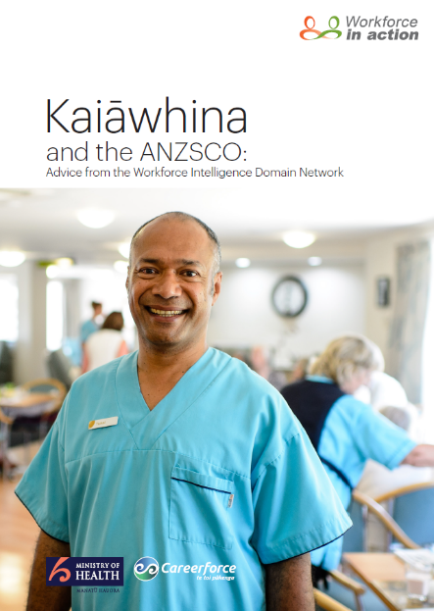
Through the Plan process an influential group of experts has been drawn together from the Ministry (Health Workforce directorate), TAS Health Workforce Information Programme (HWIP), NZACA, AUT, Te Pou, Statistics NZ, HCHA, Platform, NZDSN, Careerforce and others depending on the topic being worked on. At each stage of the work of the network the responsiveness of the Network has reflected positively on the reputation of the Ministry as a collaborative partner and helped significantly to achieve the outcomes in the Plan.
This was most powerfully demonstrated through the publication of the document Kaiāwhina and the ANZSCO - Advice from the Workforce Intelligence Domain Network to the 2019 Statistics NZ and the Australian Bureau of Statistics Review of the ANZSCO skills levels. Through the joint credibility of the Kaiāwhina Workforce Action Plan, Ministry of Health and Careerforce, along with the influence the network members have in the sector, this seminal document was prepared in a relatively short period of time and has gone on to have a direct and positive impact on the review for the ‘care and support’ occupational code.
Qualifications and Pathways
The TRoQ process led by Careerforce 2008-2014 enabled the creation of new relevant NZQA nationally recognised qualifications for the sector and the Career Development domain of the Plan has seen the outcomes of this process fully implemented.
The Kaiāwhina Workforce Action Plan had already identified that the training programmes needed to recognise, respect and uphold the existing competence of the Kaiāwhina workforce. In response, Careerforce embedded Recognition of Prior Learning (RPL) in workplace training programmes delivered using the REAL (respectful, efficient, applied, living) approach. It’s designed to develop real skills that make a positive difference to everyday work practices and outcomes.
Having successfully implemented REAL at levels 2 and 3, the ITO turned to level four and developed New Zealand’s first ever Apprenticeship Programme for Health and Wellbeing. This is an intensive programme including one on one coaching and is geared towards encouraging a whole new cohort of people into a Kaiāwhina career.
This development is seen as critical as it enables the Kaiāwhina to support people with more complex needs. The Plan provided a platform to promote the unique benefits of an apprenticeship in Health and Wellbeing. Arguably this is one of the most significant achievements of the Plan along with Pay Equity. In 2016 the first 200 apprentices joined the programme, with the first graduation in 2017, which provided a further progress and profile builder for the Ministry and the Kaiāwhina Workforce Action Plan. The establishment of the Leadership and Management qualifications that sit in a wellbeing setting and pathway, Levels 4-6 has provided another significant uplift in the career pathway options for Kaiāwhina to aspire to.
The Access and Career Development domains were the first to have actions progressed and completed. Career Development was the first domain to have all actions completed, reinforcing the Plan as a driving force in the sector and by association the Ministry as a collaborative and willing partner, connecting them with the progress for Kaiāwhina and further building the credibility and reputation of the organisation.
Working closely with the Office of the Chief Nurse, the Independent Facilitator and Responsible Owner of the Plan were able to break down some myths about the value of an integrated workforce starting with the value that Kaiāwhina and both registered and enrolled nurses bring to each other in an integrated workforce. The Kaiāwhina Health and Disability Pathway mapping document enabled the understanding of where the Kaiāwhina qualifications fit with other professions & built a pathway that enabled stakeholders to see the value of each role and also how roles could transition to others within the wellbeing sector.
Pay Equity
Without a doubt the Pay Equity and Time & Travel settlements signalled the sea change shift in value for Kaiāwhina in line with the actions identified in the Workforce Recognition domain. The achievement in 2017 of these breakthrough settlements (ARC, home & community and disability) and in 2018 for mental health & addiction workers was the result of a very significant effort from many individuals and organisations over several years with Christine Bartlett, an aged care support worker becoming the courageous champion of the pay equity cause for which she received national recognition. This was an example of the Plan not driving the settlement process but providing the place to tell the story.
Spheres of Influence and Relationships
One of the significant achievements of the Kaiāwhina Workforce Action Plan has been the development and deepening of many different influential networks and relationships which span a wide cross section of the health and disability sector. The networks are both formal and informal, some are long term and enduring while others are drawn together for a particular task or phase in the life of the Plan. What is strongly evident is that the relationship with all the entities involved has been strengthened year on year as a result of the collective work undertaken to deliver on the Plan actions. One of the tangible examples is that there are regular requests from organisations keen to have a place around the Kaiāwhina Workforce Taskforce table.
The Appendix attached to this report provides a list of organisations which have been involved in the Plan to a greater or lesser degree over the past 5 years.
Some of the formal networks are:
The Caring Counts Coalition – established post the publication of the Caring Counts report in 2012. The Coalition is Chaired by the Human Rights Commissioner and has a broad membership with aged care and home and community sector providers, consumer groups, unions, researchers (AUT), interRAI, the ITO and the Kaiawhina Workforce Action Plan. A Kaiawhina Workforce Action Plan report is provided regularly to the Caring Counts Coalition agenda which has also helped cement the relationship and uphold the credibility of both Ministry and the Plan.
The DHB Executive Leadership Networks - there are several influential DHB networks which both the Plan and Ministry have established increasingly strong relationships with over the period of the Plan. These include the GMs Maori – Tumu Whakarae; the Directors of Nursing; the Directors of Allied Health; the GMs Planning & Funding; the GMs Human Resources; the Workforce Strategy Group and others. The engagement with each of these groups provides a good example of the mutually beneficial interface between the Plan, and Ministry and the ITO as in every engagement the participants are interested in both the progress with the Plan actions and also with the Kaiāwhina career pathways and with discussing how the workforce can be prepared to meet future demand.
Health Quality Safety Commission – the relationship Ministry has with this important organisation has been significantly enhanced through the work of the Plan including the fact that Commission’s Chief Advisor – Quality and Safety is the lead of the Quality and Safety Domain.
Careerforce - during the life of the Plan there have been a number of changes in the structure and personnel at both the Ministry of Health, and Careerforce. Through the network connections, and the fact that the Kaiāwhina Workforce Action Plan has gained credibility for delivering against commitments (as reported quarterly to the former Health Workforce New Zealand Board), the network and relationships with senior leadership between both organisations have been maintained and strengthened.
Health Workforce Directorate and Brand Awareness
Less tangible is the brand awareness, the understanding of who Health Workforce is, what their purpose is, and what it does that ultimately results in more effective engagement and implementation of policy and work programmes.
In some ways the Ministry can see themselves as the lead sponsor of the Kaiāwhina Workforce Action Plan. Sponsorship is not advertising, but rather the opportunity to connect with other supporters and to be able to impact the supporter’s “purchasing” behaviour. The opportunity for deeper and more meaningful levels of engagement helps to maximise the value to a sponsorship partner. This is especially true when there is the greatest relevance between a sponsor and the sponsored product.
The “sponsorship” of the Plan has provided all of that and then some with a particular strength being attributed by stakeholders to Health Workforce for the consistency, continuity and long-term commitment demonstrated to the Plan ever since the Health Workforce New Zealand led out the co-design process in 2014. This rock-solid commitment in an environment of constant system change and sector churn has not gone unnoticed in the sector. The brand equity as a result will last well beyond the investment itself.

The Last Word
Actually, this isn’t going to be the last word on ROI because the momentum is snowballing. It is the last word in this report because it singularly summarises the progress for this once invisible, unnamed undervalued, and under qualified workforce.
It demonstrates the real return on the investment that the Ministry has made and how that investment has been realised in the transformation of a workforce.
From the Executive Summary of the Interim Report Pūrongo Mō Tēnei Wā of the New Zealand Health and Disability System Review September 2019 comes the following quote from the Review Panel:
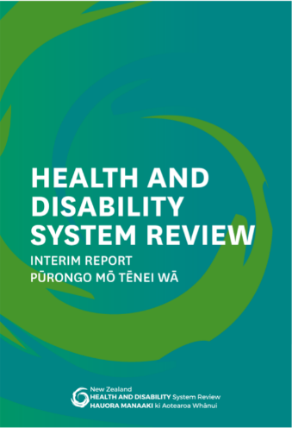
Taking a strategic approach to growing our Kaiāwhina workforce over the next 5 years will be a key to achieving a step change in the ways in which we are able to deliver services

No other workforce is named within the summary on workforce. This statement can be directly attributed to the work of Kaiāwhina Workforce Action Plan and the Ministry’s committment in making that happen.
It is great news for the sector and what is good for the sector is good for the Ministry and the Health Workforce directorate, supporting the directorate’s priorities and its framework for developing New Zealand’s health workforce.
Acknowledgement
In presenting this report the team involved in the Kaiāwhina Workforce Action Plan wish to thank and acknowledge both the previous Health Workforce New Zealand Board, the Interim Advisory Group and the recently appointed Health Workforce Advisory Board for their continuous support over the past five years.

APPENDIX
These organisations have been connected to the Kaiāwhina Workforce Action Plan for development, implementation or governance to provide feedback, promotion or guidance. They are examples of the wide-sector collaboration of the Plan and also connections made available to Health Workforce through the work of the Plan.
- Access Community Health  - Accident Compensation Corporation (ACC)  - Age Concern  - Alliance Health  - Alzheimer’s NZ  - Auckland District Health Board  - Auckland University of Technology (AUT)  - Bay of Plenty District Health Board  - Bupa Care Services  - Business Economics and Research Ltd (BERL)  - Canterbury District Health Board  - Capital and Coast District Health Board  - Careerforce  - Carers NZ  - Caring Counts Coalition  - Central Tas  - Community Care Trust (CCT)  - Corporate Academy  - Council of Trade Unions (CTU)  - Counties Manakau District Health Board  - DHB Lead Groups  - General Managers Planning & Funding (GMs P&F)  - General Managers Human Resources (GMs HR)  - Directors of Nursing (DoNs)  - Directors of Allied Health (DAHs)  - Tumu Whakarae (GMs Māori Health)  - Workforce Strategy Group  - Dieticians NZ  - Disability Services Association  - Disabled Persons Assembly  - E Tu!  - East Tamaki Healthcare  - Geneva Health  - Grey Power  - Hawkes Bay District Health Board  - Health Consumers Advisory Service NZ  - Health Quality and Safety Commission (HQSC)  - Health Share  - HealthCare New Zealand  - Home and Community Health Association (HCHA)  - Human Rights Commission (HRC)  - Hutt Valley District Health Board  - Kowhai Health Associates  - Lakes District Health Board  - Manaia PHO  - Metlife Care  - Mid Central District Health Board  - Midlands Workforce Development Hub  - Ministry of Business, Innovation and Employment (MBIE)  - Ministry of Social Development (MSD) Incl. but not limited to:  - Office for Disability issues  - Office for Seniors | - Ministry of Health (MoH) Incl. but not limited to:  - Chief Advisor Pacific Health  - Disability Support Services  - Disability Directorate  - Employment Relations  - Health System Improvement and Innovation Directorate  - Health of Older People Policy  - Health Workforce Directorate  - Māori Health Directorate  - Maori Leadership  - Mental Health and Addiction Directorate  - Office of the Chief Allied Health Professions Officer  - Office of the Chief Nursing Officer  - Office of the Director General  - Population Health and Prevention Directorate  - Populations Policy  - Primary Healthcare Implementation  - Public Health Infrastructure  - Sector Capability and Implementation  - Service Commissioning  - National Group DHB General Managers Human Resources  - National Group DHB General Managers Planning and Funding  - Nelson Marlborough District Health Board  - New Zealand Aged Care Association (NZACA)  - New Zealand Christian Council of Social Services (NZCCSS)  - New Zealand Dementia Cooperative  - New Zealand Disability Support Network (NZDSN)  - New Zealand Nurses Organisation (NZNO)  - Northern Region Alliance (NRA)  - Northland District Health Board  - Nurse Maude Association  - Nurses Executives of New Zealand (NENZ)  - Oceania Healthcare  - PHAB Association (Auckland) Incorporated  - Platform  - Public Service Association (PSA)  - South Canterbury District Health Board  - South Island Alliance  - South Island Workforce Development Hub  - Southern District Health Board  - Summerset  - Tairawhiti District Health Board  - Taranaki District Health Board  - TAS  - Te Pou o te Whakaaro Nui  - Te Rau Ora  - Tertiary Education Commission (TEC)  - Tipu Ora  - Toi Ohomai  - University of Auckland  - Waikato District Health Board  - Wairarapa District Health Board  - Waitemata District Health Board  - Walsh Trust  - WelTec  - Werry Centre  - West Coast District Health Board  - Whanganui District Health Board



www.workforceinaction.org.nz

The New Zealand Nursing Organisation Submission on the 18th Session of the Human Rights Council– Universal Periodic Review New Zealand 2013
Caring Counts, Tautiaka Tika Report of the Inquiry into the Aged Care Workforce; May 2012
BERL; Twaddle and Kahn; Health and Disability Kaiāwhina Worker Workforce 2013 Profile; 2014
BERL; Twaddle and Kahn; Health and Disability Kaiāwhina Worker Workforce 2013 Profile; 2014

